

Salesforce Commerce Cloud LINK Cartridge SFRA 20.1

Integration Guide

(v5.0.1, compatibility 19.1)

(

Salesforce Commerce Cloud LINK Cartridge Integration Guide

Shopping Cart Abandonment Integration Guide

Contents

Summary 4

Component Overview 5

Functional Overview 5

Shopping Cart Abandonment 5

Activity Tracking 5

Click / Conversion Tracking 5

Scheduled Jobs 5

Newsletter Subscription 5

Modal Acquisition 5

Use Cases 5

Click & Conversion Tracking 5

Cart Abandonment Tracking 5

Browse Activity Tracking 6

Order History Synchronization 6

Email Newsletter Subscriptions 6

Modal Acquisition 6

Customer / Product Synchronization 6

Limitations, Constraints 6

Compatibility 6

Privacy, Payment 7

Implementation Guide 8

Setup 8

Configuration 8

Import cartridge metadata 8

Custom site preferences 8

Service Profiles 9

Scheduled jobs 11

Controller integration 12

Basket Preferences 16

Custom Code 16

External Interfaces 18

Testing 18

Operations, Maintenance 19

Data Storage 19

Availability 19

Support 19

User Guide 20

Roles, Responsibilities 20

Business Manager 20

Storefront Functionality 23

Known Issues 24

Release History 25

# Summary

Listrak’s Salesforce Commerce Cloud (SFCC) Cartridge provides marketers with fully integrated ecommerce email solutions that drive revenue and customer lifetime value. By combining Listrak solutions with the features of SFCC, you are able to: recover abandoned carts with automated remarketing campaigns triggered upon abandonment, acquire more subscribers with modal acquisition, re-engage shoppers and customers with behavioral email campaigns, synchronize customers with your email list, and track customers browsing activity. The cartridge creates a connection between your SFCC store and Listrak to bring together customer behavior and order history to create targeted, data-driven email marketing to acquire new customers and sell more to existing customers.

A Listrak account is required prior to integration of the cartridge. This cartridge extends the functionality of a SFCC storefront by synchronizing data points to a Listrak account. This data is used to deploy email marketing campaigns such as: shopping cart abandonment, post purchase emails, targeted customer segments and more.

This cartridge also provides additional acquisition strategies to build your email marketing list. It will synchronize subscriptions to ensure your Listrak account is always updated with new additions. All subscriber removals will occur through the Listrak removal links embedded in emails.

The cartridge integration process involves several steps including:

* **Import custom objects** – to store data and settings
* **Import custom preferences** – to store configuration values
* **Import service profiles** – to store FTP and HTTP service settings
* **Integrate controller code** – to tie into shopping events like adding to the cart and completing an order
* **Schedule job creation** – to send failed requests to Listrak and export order/catalog data
* **Locale support** – all locales are supported

# Component Overview

## Functional Overview

### Shopping Cart Abandonment

As shoppers add items to their cart, a session is created and tracked by the Listrak cartridge. If the customer does not complete a purchase before leaving the site, the session will be marked as an abandoned cart. If an email address was attached to the shopping cart, Listrak will trigger a cart abandonment email series.

### Activity Tracking

As shoppers browse your store and look at products, the Listrak cartridge will log this activity and store it for marketing campaigns. JavaScript generated on your site by the cartridge will capture events to send to a Listrak endpoint so that no information is stored within your SFCC instance.

### Click / Conversion Tracking

When a visitor arrives at the storefront as a result of a click on an email sent from Listrak, a cookie is set for that session. If an order is completed within 30 days, the originating message is credited with the conversion revenue.

### Scheduled Jobs

Data is sent to Listrak on a continuous basis by scheduled jobs. Order history is exported regularly and sent to Listrak. Customer and product information is exported to file and uploaded to Listrak daily using the SFCC FTP client.

### Newsletter Subscription

The Listrak cartridge enables merchants to push data to Listrak as customers complete forms to subscribe to a newsletter. These form elements are configured as custom objects through the BM and added as hidden fields to any existing form.

### Modal Acquisition

Functionality is included to display a modal popup to request customers to sign up to an email marketing list. The popup configuration is controlled within the Listrak application but code is inserted into pages by the cartridge to ensure the popup can appear anywhere.

## Use Cases

### Click & Conversion Tracking

Upon receiving an email sent from Listrak, a subscriber clicks on a link to the SFCC storefront. The cartridge will identify this click and set a session cookie for that shopper. The shopper adds items to their cart and continues to complete their purchase. The cartridge will assign the tracking cookie to their order. As order history is exported and uploaded to Listrak this session identifier is included allowing reporting to attribute the order back to the original message.

### Cart Abandonment Tracking

Once a shopper adds an item to their shopping cart, the cartridge will assign them a unique session ID. As the shopper travels through the site, this session is updated with activity. Once they decide to checkout and enter their email address during checkout, the session is associated with that email. If they decide to leave the checkout process, once the session reaches an inactivity threshold, it is identified as an abandoned cart. After abandonment, Listrak will trigger a series of emails to recover the shopper.

### Browse Activity Tracking

The Listrak cartridge will capture any shopper activity on your site, including products browsed. This information will be available for marketing campaigns through recommended products in emails and on your website. Browsing activity can also trigger an abandonment campaign based on recently viewed products.

### Order History Synchronization

In order for merchants to better understand buying habits of their customers, all orders placed in a SFCC storefront will be sent to Listrak on a continual basis through an export and FTP upload process.

Once the order history job runs for the first time, it will export up to 30 days of order data to upload to Listrak. Subsequent runs will only upload orders modified since the last export. It is recommended that new customers work with their Listrak project manager to upload order information that is older than 30 days.

### Email Newsletter Subscriptions

SFCC merchants will create custom email signup objects for each subscription form on their site. Once a hidden form field is included in the HTML template and Listrak code is included in the form processing controller code, any visitor submitting their email address will be sent to Listrak to be added to the designated email list potentially triggering a welcome series of emails.

### Modal Acquisition

If a modal acquisition popup is defined for a merchant, a visitor will see the signup form in a popup window where appropriate. Once they enter their email address and submit the form, the data is sent to Listrak, again potentially triggering a welcome series of emails.

### Customer / Product Synchronization

Every day, a scheduled job will send customer and product catalog information to Listrak. This information can be used to dynamically populate messages with personal and relevant information.

Once the Customer Synchronization job runs for the first time, it will export up to 30 days of customer data to upload to Listrak. Subsequent runs will only upload customers modified since the last export. It is recommended that new customers work with their Listrak project manager to upload order information that is older than 30 days.

## Limitations, Constraints

This cartridge requires the usage of an outbound FTP connection from the SFCC storefront. A support ticket may be required to open this method of communication. Instructions for submitting a support ticket can be found here:

[https://xchange.SFCC.com/docs/DOC-19143](https://xchange.demandware.com/docs/DOC-19143)

## Compatibility

The Listrak cartridge was developed and tested on SFCC 20.4, compatibility mode 16.1 and 19.1.

Privacy, Payment

No credit card data is stored or transmitted by this cartridge. Some customer information will be transferred including: email address, first and last name.

# Implementation Guide

## Setup

To import the cartridge into your store, within UX Studio select **File** -> **Import…** and choose **Existing Projects into Workspace** and click “Next” Find the *int_listrak_sfra, int_listrak_core,* and *bm_listrak* folders on your computer and complete the import process.

Once the cartridge is imported, you must assign Listrak to the cartridges within your storefront settings. In the Business Manager (BM) navigate to **Administration** -> **Sites** -> **Manage Sites** and select your site. Under the settings tab, add “:int_listrak_sfra:int_listrak_core:” to the existing **Cartridges** and click “Apply.”

Under business manager cartridges, add “:bm_listrak:” to the existing **Cartridges** and click “Apply.”

You must also assign the cartridge to the Business Manager for the scheduled jobs to be available to run. On the same page listing your sites, a separate area to manage the Business Manager Site will be below. Click the link to manage the **Business Manager** site. In the input for cartridges, add “:bm_listrak” to the input and click “Apply.”

## Configuration

### Import metadata

To import the metadata used by the Listrak cartridges, login to the **Business Manager** and navigate to **Administration** -> **Site Development** -> **Site** **Import & Export** and click the “Upload” button. Find *int_listrak_metadata.zip* on your computer and upload the file. Select the same file from the list and click the “Import” button on the bottom right of the panel. This will import all cartridge specific settings from custom site preferences, jobs, services and credentials

### Custom site preferences

These preferences configure the way a SFCC storefront communicates with Listrak. To enable/disable the cartridge, you must set the below flag to Yes or No respectively:

* **Enable Listrak Cartridge**

To properly link your SFCC account to your Listrak account, you must enter the Listrak Merchant Tracking ID below:

* **Listrak Merchant Tracking ID** - <<MERCHANT_ID>>

If you are utilizing the Listrak Shopping Cart Abandonment and/or Activity Tracking Service, you must enable these modules by checking the following fields:

* **Enable Shopping Cart Abandonment**
* **Enable Activity Tracking Service**

It is recommended that you configure your Listrak cartridge to perform Product, Customer and Order data synchronizations. To do so, you must check the following fields and enter your Listrak FTP user name and password:

* **Enable Product Sync**
* **Enable Customer Sync**
* **Enable Order Sync**
* **Top Level Category Index**
* **Product Sub-category Levels to export**

**Subscription forms –** Enter each form’s HTML name or id for this setting for the form data to be submitted to Listrak as subscription information. Typically, this can include the customer’s email address, first name, last name, address information, etc.

**Email capture fields** allow the cartridge to identify shoppers even if they do not submit their email address during checkout or login to their account. We recommend the following fields added for email capture if you are running a standard checkout process:

* dwfrm_profile_customer_email
* hpEmailSignUp
* login-form-email
* dwfrm_billing_creditCardFields_email
* trackOrderEmail
* email

**Order Status Filter** allows the cartridge to filter out orders based on their order status so they are not sent to Listrak. For example, If you don’t want orders that are in a cancelled state to be sent to Listrak, you can add Cancelled to this field. You can add as many statuses as you want. Some example statuses below:

* Cancelled
* Completed
* Failed

**Email Watermarks** prevent the cartridge from submitting watermark text that may be submitted to the email signup or email capture processes that are not email addresses. For example, if you use a watermark “Enter email here”, it is possible in some browsers for this data to be submitted by the user. Add “Enter email here” to the watermarks list to prevent this from being submitted.

**Use Absolute Product URLs** will send fully qualified product URLs to Listrak for use in your emails. The default behavior is to not use Absolute product URLs and is also the recommended setting. In some rare cases it may be necessary to use Absolute product URLs. Please consult with your Listrak project manager if you believe you need to use Absolute product URLs.

**Use Absolute Image URLs** will send fully qualified product image URLs to Listrak for use in your emails. If you are using the SFCC content delivery network you must use absolute Image URLs for your product images to appear properly in your emails.

**Product Image View Type** allows you to specify which image URLs will be sent to Listrak. The default behavior is to use the “small” image view type if it is available, and the “large” item view type if “small” is not available. If you use a custom view type you may specify it here.

**Enable Exception Logging** allows you to enable the use of custom objects to log server side exceptions. These custom objects used go against the custom objects quota as defined by SFCC.

**Additional Product Attributes** provides the ability to export additional product attributes in the daily Product file in addition to the standard options. Simply add the attribute name, i.e. product_style

**FTP Filename Prefix** allows a store specific prefix appended to the data export filenames. Use this field when multiple stores are using the same **Listrak Merchant Tracking ID**, i.e. Store1_

### Service Profiles

Service profiles set up parameters for use in things like FTP and HTTP calls made by Listrak’s SFCC cartridge. These settings specify values for things such as the FTP server endpoint, FTP credentials, and the timeout for making FTP and HTTP requests.

Navigate to **Administration -> Operations -> Services**. There, ensure that two service profiles for Listrak exist under the Services tab; One for *listrak.ftp* and one for *listrak.http*. Each profile defines the service type, a log prefix, and a profile and credentials mapping. Both the Listrak FTP and Listrak HTTP services utilize the same settings profile which defines things such as timeouts for requests. The Listrak FTP service uses a credentials file which denotes user FTP settings for exporting files to Listrak. The Listrak HTTP service does not utilize a credentials mapping.

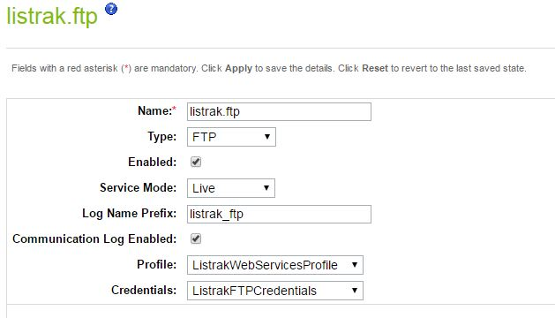

Click on the Profiles tab and verify that a single *ListrakWebServiceProfile*  entry exists. You may click through on the link to view and change the default settings.

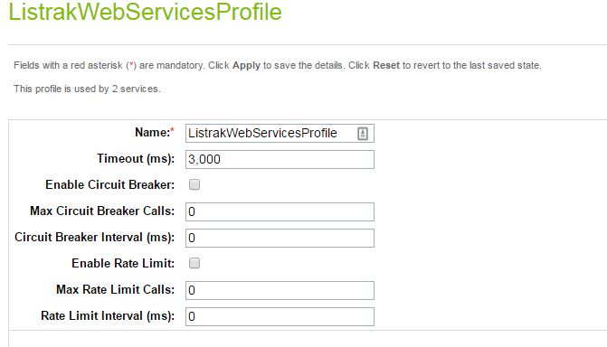

Finally, click on the Credentials tab and verify that a single, *ListrakFTPCredentials* profile exists. Click through on the link to view and update the settings.

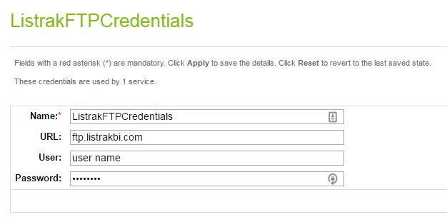

Enter your FTP username and password in the designated fields. If you do not know your credentials, contact your Account Manager. Once finished, click the “Apply” button to save your settings.

Both the Listrak FTP and HTTP services use the same service profile for simplicity. If you would like each service to have different settings, such as a different timeout value then you will have to create a new service profile and assign that to whichever service you want to use it with.

More information on how to set up and assign service profiles to services can be found at the official [SFCC](https://documentation.demandware.com/DOC1/index.jsp) Documentation repository under **SFCC 16.6-> Developing your storefront -> Web services.**

### 

### Scheduled jobs

You must assign each job to the site(s) you want to export data for. From Administration > Operations > Job Schedules, choose one of the new Listrak jobs (prefixed with “ltk”). Click the Step Configurator tab on the job scheduling screen. Click on the **RefArch** button and in the drop-down menu, choose the sites you want the job to run on. Click assign to save.

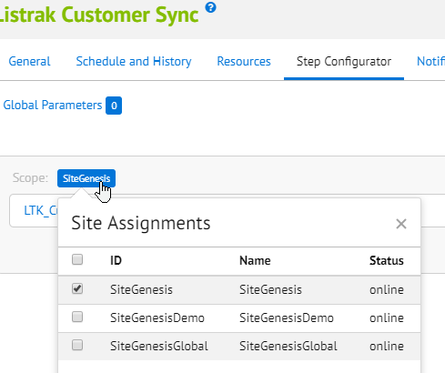

### Cartridge Integration

The int_listrak_sfra cartridge uses extension methods for the existing core functionality of the Mobile First Architecture controllers. As such, the cartridge should layer properly over other custom cartridges.

We do provide an overridden pageFooter.isml template file that contains one line of code required for the integration. You will have to add this to the end of your footer template file if it has been customized, right above the closing </footer> tag.

Code Snippet: <isinclude url="${URLUtils.url('ltkInclude-Start')}"/>

productDetails.isml also has a custom snippet of code at the top that needs to be added to your cartridge’s version of the template

<isinclude url=*"${URLUtils.https('ltkActivityTracking-TrackRequest', 'pid', pdict.product.id)}"*/>

**List of extended controllers and methods.**

Cart.js

* AddProduct
* RemoveProductLineItem
* UpdateQuantity

CheckoutAddressServices.js

* AddnewAddress

CheckoutServices.js

* PlacerOrder

Product.js

* Show

### Basket Preferences

To ensure that baskets are retained for the full cart abandonment email series, we recommend the basket lifetime be set to 7 days and persistent for all customers. This setting can be changed by navigating to **Site Preferences** -> **Baskets** within the BM. Set the following:

* **Basket Persistence** – basket persistent for all customers
* **Basket Lifetime** – 10,080 minutes (7 days)

## External Interfaces

Session, conversion, email capture, and activity (page and product browse) data is sent from the storefront to Listrak via the referenced client side JavaScript referenced by the remote include on page 14. Previous versions of the Listrak SFCC Cartridge had sent this data via SFCC HTTP requests.

The FTP client is used to upload order history files and customer/product data synchronization purposes. As noted previously, outbound FTP access is required to send data to Listrak and may require opening a support ticket with SFCC. Instructions for submitting a support ticket can be found here:

[https://xchange.SFCC.com/docs/DOC-19143](https://xchange.demandware.com/docs/DOC-19143)

## Testing

All testing will be outlined by your project manager during the project kickoff meeting with the Listrak Professional Services team.

# Operations, Maintenance

## Data Storage

As errors are trapped by controllers, they are logged to the ltk_messageObject (assuming the **Enable Exception Logging** custom setting is enabled). This data object is continuously purged by a scheduled job. The messages are utilized to troubleshoot any integration issues that may arise during setup or daily operation.

All files exported for FTP upload to Listrak are stored in a folder created in the import/export directory. These files are deleted upon successful upload to Listrak.

All relevant email subscriber and customer order history data is stored within Listrak databases and may be purged at the merchant’s request.

## Availability

Listrak’s endpoint infrastructure is configured for maximum availability. All requests aside from email newsletter signup are sent via the included client side JavaScript. To ensure 100% transmission, email newsletter signups are sent to Listrak via server side HTTP requests. In the event that HTTP requests are not successfully accepted by the endpoint, they will be stored in the custom Listrak data object. Failed requests will be processed by the scheduled job to ensure synchronization is achieved as quickly as possible once availability returns.

Additionally, monitors from Listrak notify developers in the event data is not received from a SFCC deployment for a specified amount of time, thus alerting us of potential failures in transmission.

## Support

The primary contact person for all defect fixes or improvements is your project manager. If you do not have a project manager, you may contact Listrak support by calling 717-627-4528 ext. 1 or emailing [support@listrak.com](mailto:support@listrak.com).

# User Guide

## Roles, Responsibilities

Once the scheduled jobs are created in the Business Manager, no recurring tasks are required by the merchant.

## Business Manager

**Scheduled Jobs** – all scheduled jobs are imported and do not need any additional configuration changes.

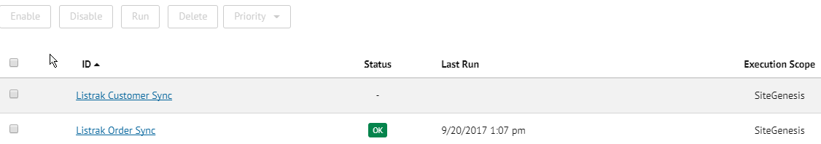

## 

## Storefront Functionality

While most of the cartridge functionality exists behind the scenes, some storefront functionality is exposed, primarily in the form of JavaScript.

**JavaScript Inclusion** – by placing a remote include reference in the footer of the site, Listrak’s JavaScript framework will be loaded on all pages. It will also render JavaScript code to capture email addresses as they are typed for the shopping cart abandonment program, and to track shopper’s browse activity.

**Modal Acquisition** – the popup settings are controlled within Listrak and will display a modal dialog under the defined conditions. The functionality for the popup is provided by the inclusion of JavaScript as mentioned above.

# Known Issues

**Product Sync:** Depending upon user implementation product image urls may not be exported in the correct format. This may require customization of ltkProductSync.ds to correct.

# 